

Lesson 5 Lesson-End Project
Building a Maven Project with Jenkins

Project Agenda: Use Jenkins to create a Maven build job which will compile and run a local Maven project.

Description: You are a DevOps engineer, and you are asked to create a sample maven project, add a sample java code in it, and deploy the same on Jenkins.

Tools required: Git, GitHub, and Jenkins

Expected Deliverables:
The program should be built with Maven.
The build job should be designed to build a local project.
The build job should compile and run the code if the build succeeds.

Steps to be followed:
- Install Maven and create a Maven project
- Create a Jenkins build job to build a Maven project
- Build a Maven project in Jenkins

Step 1: Install Maven and create a Maven project
  - Open the terminal.
  - If you do not have Maven installed already, run the command, sudo apt-get install maven.
  - Run the command mvn -version to verify the installation.

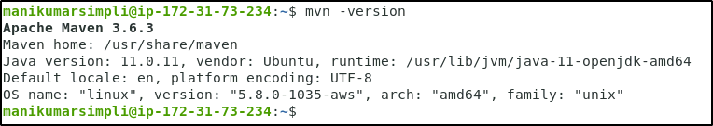

  - Go to https://start.spring.io/ link.
  - Select Maven project and Java as a language.
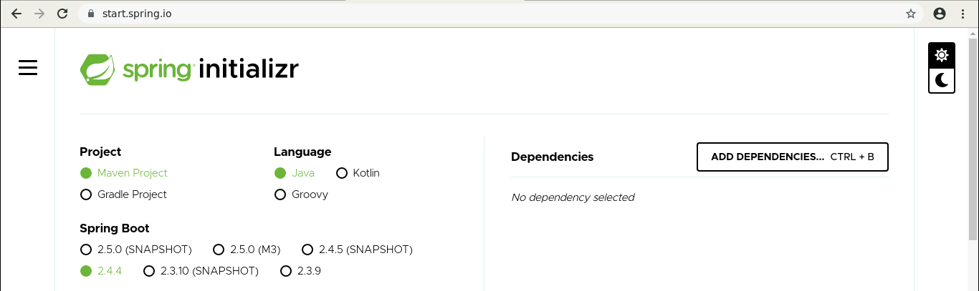

  - Provide the required information. Select Java 11.
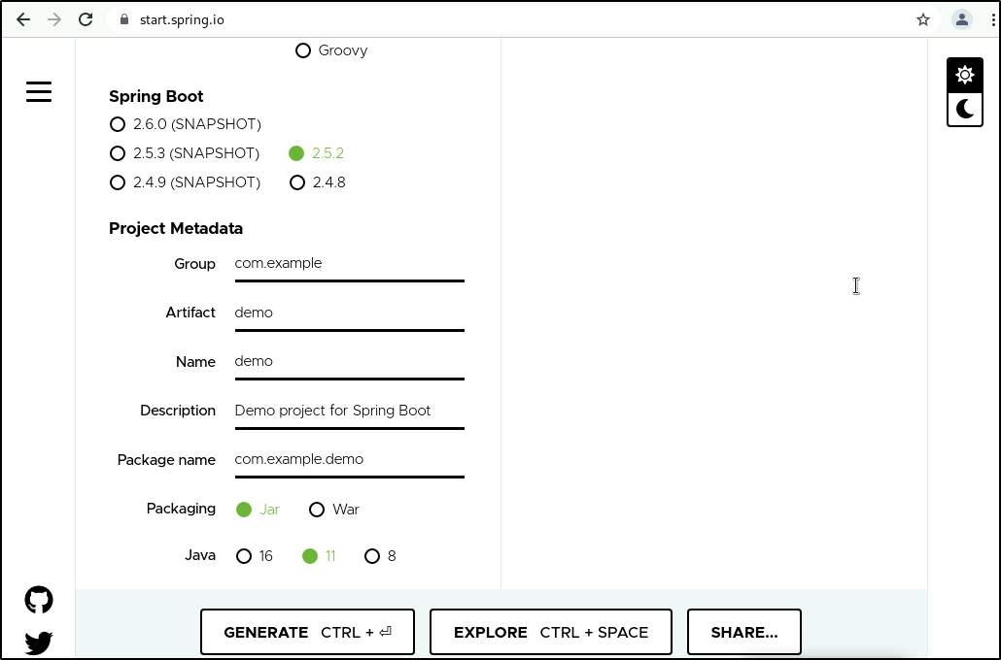

  - Click on GENERATE CTRL+. The zipped file will get installed in your lab.
  - Unzip the folder at /home/<labuser> location.
  - Once the command is executed, run cd url-checking
  - Inside the project directory, run ls and find the pom.xml file.

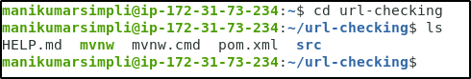

  - Open App.java in a text editor. Example: vi App.java

  - Replace the contents with the below code and save it:

package com.simplilearn.app;

import java.io.IOException;
import java.net.HttpURLConnection;
import java.net.URL;

public class App{

public static String checkResponse(String url) throws IOException{

HttpURLConnection connection = (HttpURLConnection) new URL(url).openConnection();

connection.setRequestMethod("HEAD");
int responseCode = connection.getResponseCode();
String response = "Success";
if (responseCode != 200) {
response = "Failed";
}
return response;
}

public static void main(String[] args) throws IOException{
System.out.println(checkResponse("https:/"+"/samples.openweathermap.org/data/2.5/weather?q=London,uk&appid=b6907d289e10d714a6e88b30761fae22"));
}

}

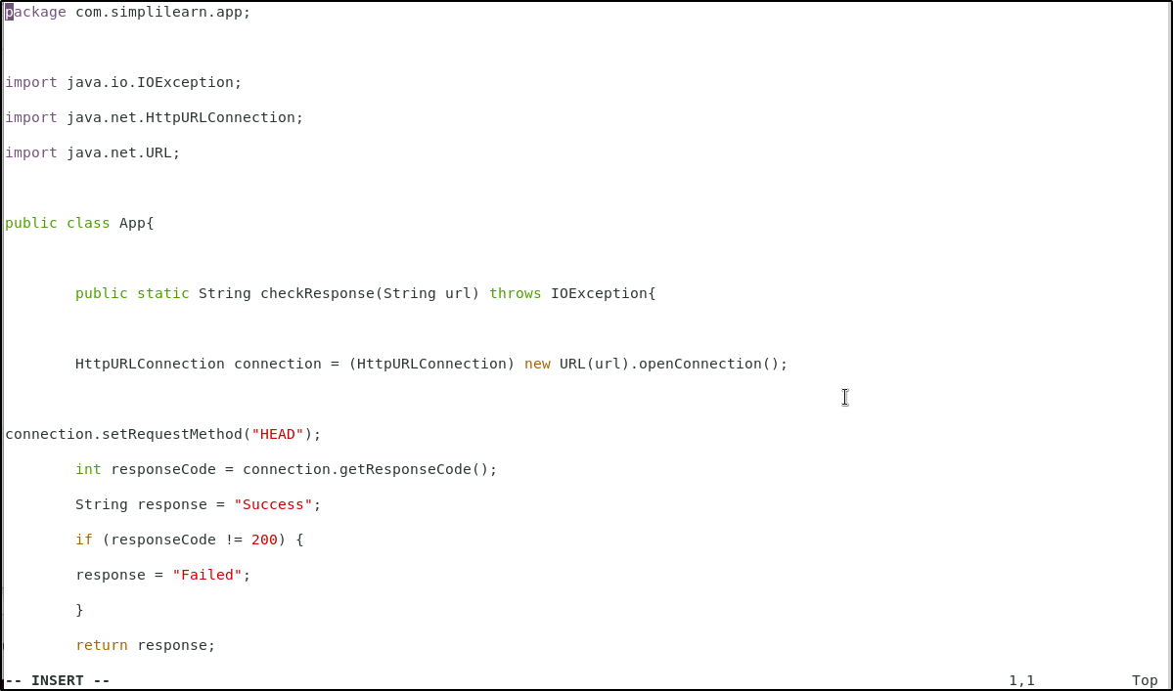
  - Click on esc and type :wq to save the file.

Step 2: Create a Jenkins build job to build a Maven project
  - Open the browser and go to Jenkins dashboard by typing localhost:8080 in your browser.
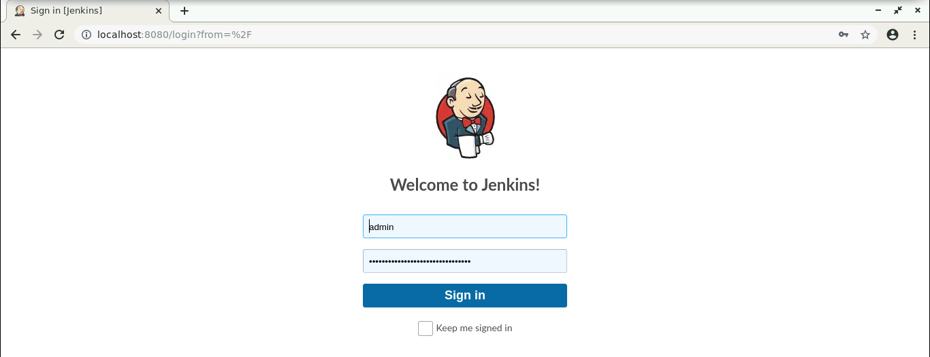

  - Provide the credentials and click on Sign in.
  - Click on New Item in the Jenkins dashboard.
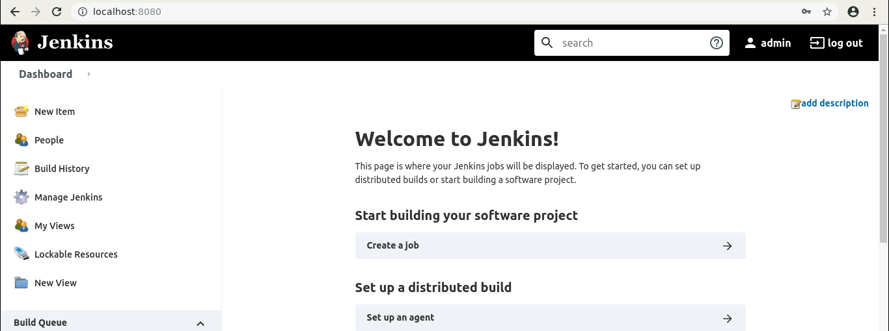

  - Enter a name for your project.
  - Select Maven project as the build job type.

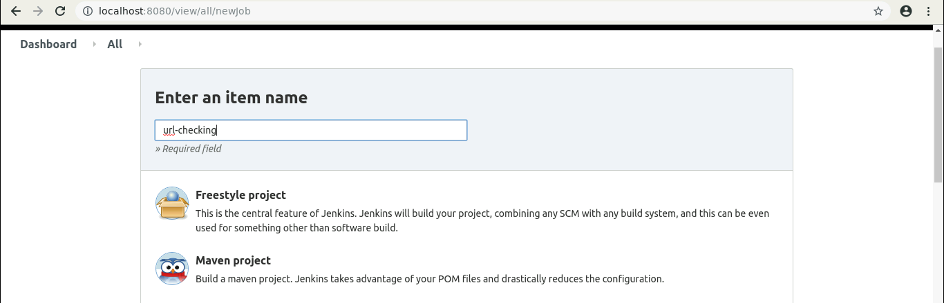

  - Click OK.

  - Keep the defaults and scroll down to the Build section.
  - Enter the path to the pom.xml.

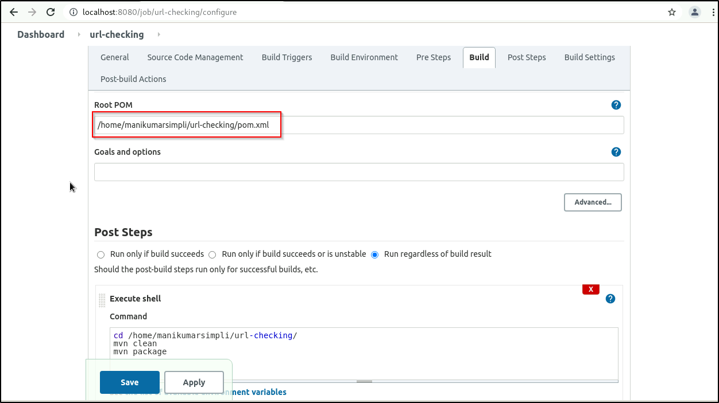

  - Scroll down to the Post Steps section.
  - Click on Add post-build step and choose Execute shell from the drop-down menu.

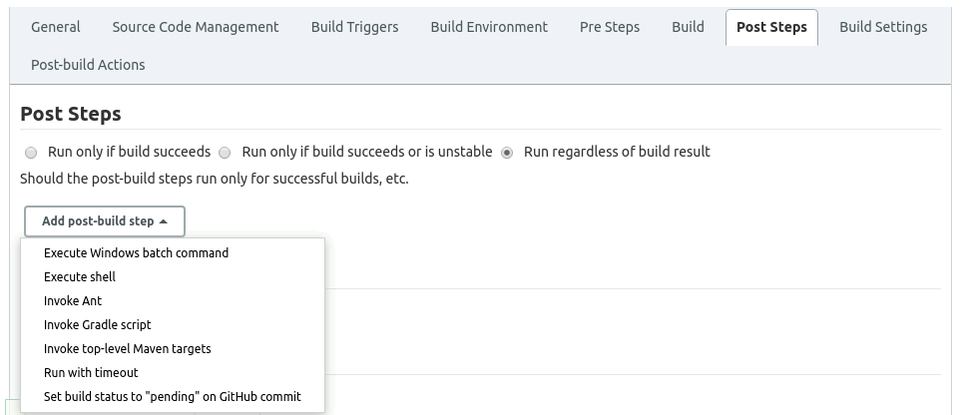

  - Enter the following commands in the command section:
cd /home/<labuser>/url-checking/
mvn clean
mvn package
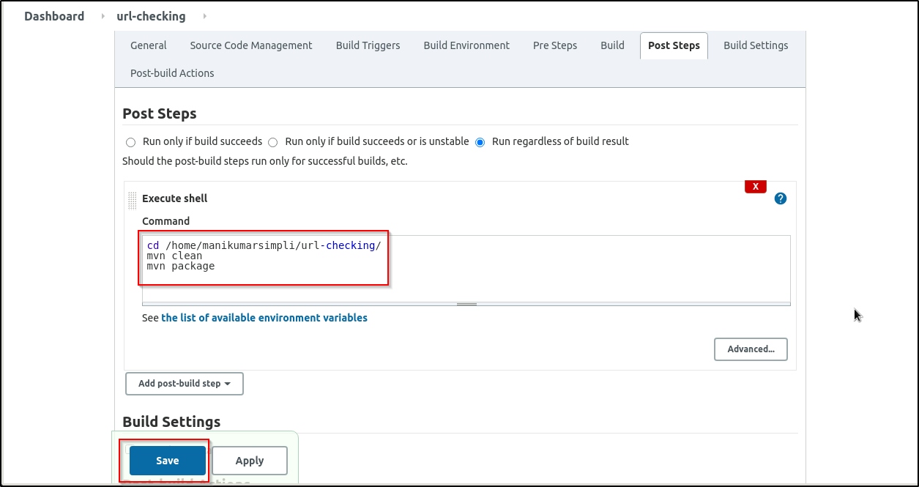

  - Click Save.

Step 3: Building a Maven project in Jenkins
  - Open a new terminal and type chmod -R 777 url-checking command.
  - Go to Jenkins Dashboard, and click on the project name.
  - Click Build Now in the project window. Jenkins will now build your project.

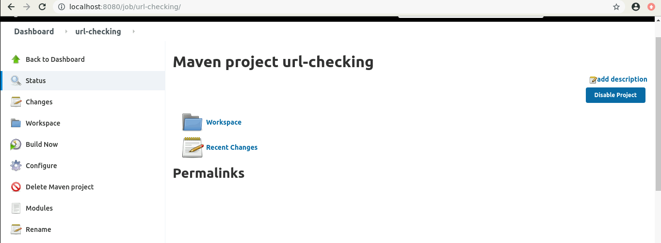

  - Click on the Build History to view the build results.
  - Click on the Console Output to view the build logs.

